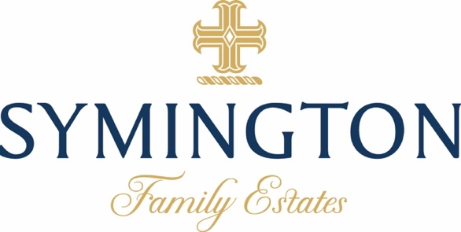

The Douro Valley on track for a great quality harvest

Following a succession of challenging harvests in the Douro with prolonged heatwaves and low yields, we are currently well placed to have one of the highest quality vintages in recent years. While much of southern Europe experienced intense heatwaves over this summer, Portugal was largely spared. July temperatures for the whole country were close to normal, while the Douro was fractionally below average. The region benefited from an anticyclone that generated strong northerly winds (known as the ‘nortada’), which brought cooler maritime air and more humid conditions (see surface air temperature map for July below).

The growth cycle this year has been largely favourable, with abundant rainfall through the winter and late spring replenishing the soil water reserves, after one of the driest years in 2022. Although there was no rainfall through July and August, the combination of reasonable soil moisture and moderate temperatures, have delivered good levels of acidity, balanced maturations, and positive phenolic development.

We started our harvest in the Douro on the 21st August by picking Viosinho white grapes at our high-altitude estates in the Cima Corgo sub-region. In the last week of August, we began harvesting red grapes (Sousão, Tinta Roriz and Touriga Nacional) from select plots of vineyard across our estates in the eastern Douro Superior sub-region. We have now started harvesting across all our principal estates, following some almost perfectly timed rain across the entire Douro Valley on the 2nd and 3rd September, which will be beneficial for final ripening of the grapes and development of colour, tannins, and aromas in the wines.

With maximum temperatures of 30ºC and cool nights forecast for the first few weeks of September, we are expecting to produce some great quality wines, particularly in the sub-region of the Cima Corgo.

Charles Symington, Head Winemaker & Production Director | Symington Family Estates

Fig.1: Surface Temperature Anomalies - Euro-Atlantic Region · July 2023
Source: EU Copernicus Climate Change Service

ABOUT SYMINGTON FAMILY ESTATES

The Symingtons of Scottish, English and Portuguese descent have been Port producers in northern Portugal since 1882. For 5 generations they have combined their passion for producing fine wines and Ports with a deep commitment to the region’s land and people. Today, ten Symingtons work across their four Port houses: Graham’s, Cockburn’s, Dow’s and Warre’s, as well as their Douro wine brands – Quinta do Vesuvio, Quinta do Ataíde, Altano and Prats & Symington (of Chryseia fame). In 2017 they launched a new venture, Quinta da Fonte Souto, in the Alto Alentejo.
Symington Family Estates is a leading premium Port producer and the leading owner of prime vineyard in the Douro valley, with 26 Quintas covering 2,462 hectares and 1,114 ha of vineyard. The family business is a founding member of Primum Familiae Vini – an association of 12 European wine families – and in 2020 was voted in 7th place in The World’s Most Admired Wine Brands list by a panel of over 200 international wine experts organised by Drinks International.
All Symington vineyards are sustainably managed under a minimum intervention certification and 130 ha are organically farmed – the largest area of organic vineyard in northern Portugal. The family have invested significantly in viticulture R&D to adapt to climate change and have an ambitious sustainability plan, with a series of public goals under the banner of Mission 2025. In 2019 the company became a certified B Corporation – the first wine company in Portugal to take this step – joining a global community of businesses audited for the highest standards of social and environmental responsibility. Symington was named Ethical Company of the Year in The Drinks Business 2019 Green Awards.
More information:

- www.symington.com
- www.instagram.com/symingtonfamilyestates
- www.twitter.com/SymingtonFamily
