Douro Harvest Report
Symington Family Estates
2011
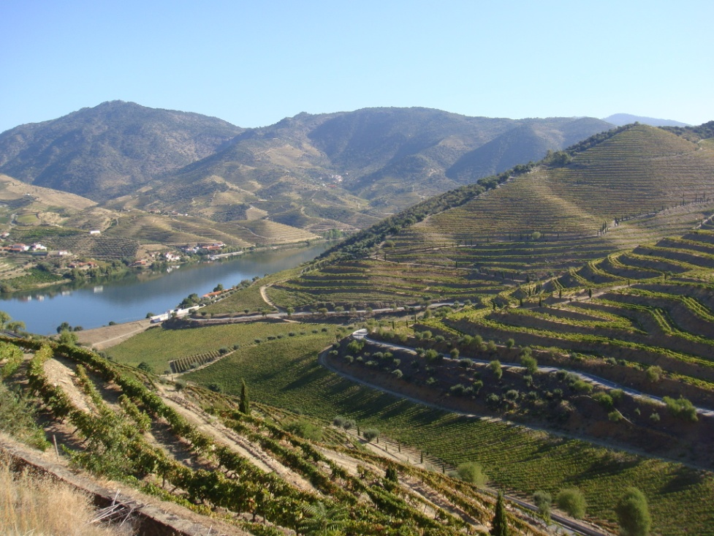
There are smiles on the face of wine makers across the Douro as this year’s harvest winds down on yet another day of warm autumn sunshine and our valley has never looked more beautiful. It has been an extraordinary vintage; since the night of the 1st September there has not been a drop of rain in the Douro, we have harvested our grapes under lovely blue skies day after day for five weeks.
The viticultural year was challenging to start with. Every month this year saw rainfall that was significantly lower than average and by the end of August we had just 250mm in 8 months at Quinta do Bomfim compared to the mean of 403mm (-38%). But yet again what the older generation have always told us held true; the rains of the last three months of the previous year are crucial in establishing the water tables deep down in the schistous rock; from October to December 2010 we had a very good 358mm, 50mm more than the average. So the challenging shortfall of rain this year was compensated by the reserves we had in the bedrock of our vineyard soils. It is for this reason that the very warm April and May encouraged early flowering and fruit set from healthy looking vines.
But the warm weather in the spring encouraged oidium and mildew. Substantial damage was caused to localised vineyards across the Douro by these fungal infections to those who were not careful, or to those who could not afford the considerable cost of the treatments. To add to these difficulties, June bought some violent hail storms. One of the worst storms hit our Quinta de Ataide in the Vilariça valley on the 5th June and shredded part of the vineyard. As if that was not enough, we then had a sudden burst of intense heat. The temperatures had been in the mid-20⁰’s C for much of June, but on the 25th and 26th June the temperatures suddenly rocketed over 40⁰C. In the words of our viticultural researcher Miles Edlmann ‘The vines were completely unprepared for this thermal onslaught, and it inflicted widespread and very intense sunburn on the fruit, leading to the complete abortion, followed by immediate desiccation, of many of the bunches in the space of a weekend…not even the oldest caseiros can remember having seen sunburn quite like it’. To give an idea of the intensity of this heat, there was a public row in Lisbon and Oporto, because citizen’s groups complained that no public warnings had been given for the very low ozone levels over these two days. All these various challenges reduced yields across the Douro, but of course have no impact on the quality of the fruit.
Thankfully July was only moderately warm, with temperatures at an average of 23.9⁰C compared to the mean of 24.7⁰. But we had no rain. This has become something of a pattern over recent years and brings additional problems; all the very young vines that we had planted back in March had to be individually watered at considerable cost (€0.23 per vine, on a new 4 hectare vineyard will cost €3,732.00). August started nicely warm, but again with no rain whatsoever and thankfully no excessive heat.
By now there was a lot of chat in the Douro (as elsewhere across Europe) predicting a very early start for picking. But some people look only at the Baumés and get carried away and fail to look at the phenolic ripeness. Green stalks and green pips do not make good wines, even if the sugars are high. 2011 looked to be a re-run of some recent years, where the severe lack of humidity distorted the maturation. A vine cannot ripen its sugars as well as its tannins if there is a drastic water shortage.
On Sunday afternoon 21st August we were dealt the ace of spades; a large Atlantic storm blew in from the West over the mighty 1,400 meter high Serra do Marão. For much of the day the skies looked dark and threatening and it was quite possible that the storm would move on over the Douro into Spain without depositing any water. But at about 7pm, the heavens opened and in the next few hours 34 mm fell at Cavadinha, 18.2mm at Bomfim, 10mm at Malvedos and 21.8mm at Vesuvio. This was simply superb timing, the vines greedily absorbed the longed-for moisture and the Baumés dropped quickly over the following days while the skins softened after more than 8 weeks of trying to protect the little moisture that was in their berries.
The wiser heads in the Douro began to revise their initial early picking dates. Then we got another bonus, 18mm of rain on the 1st and 2nd of September. This was decisive as far as we were concerned. My cousin Charles Symington, responsible for our vineyards and winemaking, pushed back all picking dates by approximately a week to allow this rain to really benefit the vines. We had to accept the considerable risk that the autumn weather would become unsettled, resulting in the fruit quality quickly deteriorating. The arrival of the picking teams was put off, again a logistical risk as some may decide to go elsewhere. We looked anxiously at the various ten-day forecasts on the internet every day.
It was a risk worth taking because we have seldom seen such perfect harvest weather as we have had over the last 5 weeks. The grapes were in superb condition, with good Baumés and ripe phenolics right through the harvest. It was immediately clear that very good wines were being made; the colour at the very early stage of fermentation was excellent and improved right the way through September. The aromas in the wineries were simply wonderful. Our winemakers often say that the Douro is having a great year when the Touriga Franca (a late ripener) is giving great musts, this year it did.
The summery weather did bring some problems and September was half a degree hotter than average, the grapes harvested in the morning were coming into the wineries at a pleasant 21⁰C, but by the afternoon they were often at 25⁰C or more. Cooling the must was essential in order to get the right fermentation temperature curve. While a little raisining is beneficial for great Port, it is not welcome for Douro red wines. So we were busy on the sorting tables for the best wines this year. The French ‘Mistral’ machines at two of our Douro DOC red and white wine wineries (Roriz and Sol) was an investment that paid off handsomely. The Mistral rejects any raisined grapes and only perfect berries make it past the sorting tables where our own selection teams continue to work before and after the Mistral, to give even better selection.
If it was not for the serious underlying problems, we would all be extremely content. But sadly the harsh environment of the international wine market and the powerful downward price pressures imposed by major international customers has impacted severely on the Douro farmer’s livelihoods. The situation has not been helped by poor planning from the authorities; while Port sales have stabilized over recent years, the Ministry of Agriculture continued to allow additional planting in the Douro over the last decade, creating an excess of grapes that has been nothing short of catastrophic for the farmers. It remains to be seen whether enough courage and ability exists to implement the necessary reforms so that the Douro can have a viable future.
Returning to the question of the Ports and Douro DOC wines made this year, it can be said that this has been a good and very possibly a great year in the Douro. The last lagar at Quinta de Cavadinha in the Pinhão valley is still fermenting as this report is being written, so the wines will need to be assessed over the coming months, but here is no doubt some very exciting wines have been made in 2011.

Paul Symington.
Portugal 10th October 2011
